SCHOOL OF COMPUTING

DIPLOMA IN INFORMATION TECHNOLOGY

ST0509 JAVA PROGRAMMING

2020/2021 SEMESTER 2
PRACTICAL ASSIGNMENT

Objective of Assignment

To allow students to practice what they have learnt in the module by developing a Java program to simulate an Event Management app.

Instructions and Guidelines:

- The assignment should be done individually and will account for 30% of your final grade.

- The assignment should be submitted by Sunday, 3 Jan, 11:59 pm.

- The development platform will be in Java using NetBeans IDE.

4. The interview will be conducted during the practical lessons on week 12. You are expected to explain the program logic and modify the program during the interview. If you are absent from the interview, you will be awarded zero mark for the assignment.

5. No marks will be awarded, if the work is copied or you have allowed others to copy your work.

6. 50% of the marks will be deducted for assignments that are received within ONE (1) calendar day after the submission deadline. No marks will be given thereafter.

Warning: Plagiarism means passing off as one's own the ideas, works, writings, etc., which belong to another person. In accordance with this definition, you are committing plagiarism if you copy the work of another person and turning it in as your own, even if you would have the permission of that person. Plagiarism is a serious offence and disciplinary action will be taken against you. If you are guilty of plagiarism, you may fail all modules in the semester, or even be liable for expulsion.

Overview of the system

You are tasked to develop a Java program to simulate an Event Management system. There are two types of the users: Administrator and Normal User.

The example below shows an example of an Event Management system that allows administrators to display, add or delete events and to allow users to display, search and register events.

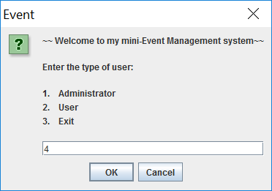 | 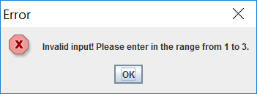
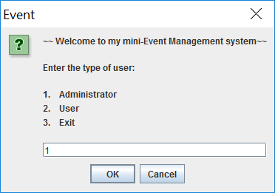 | 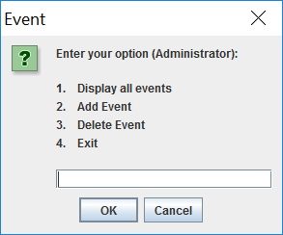
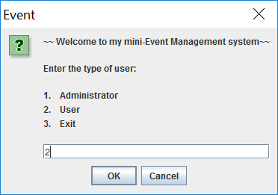 | 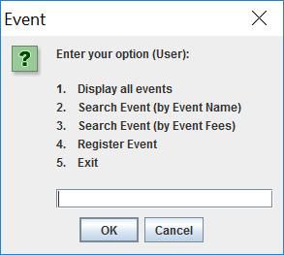

Figure1.1: The program allows the user to enter the type of the user and then display the options accordingly. You should validate the user inputs. If the input is invalid, it displays an error message and prompts the user to re-enter.

Figure 1.2 to 1.5 shows what an Administrator can do.

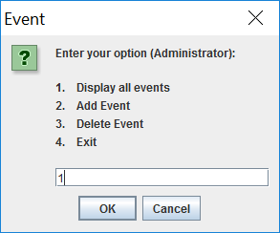 | 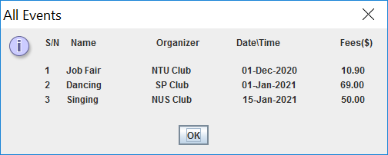

Figure1.2: The program displays all events if the administrator selects option 1.

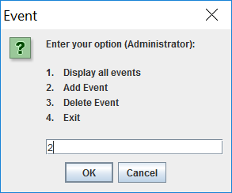 | 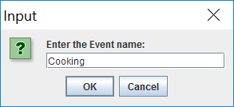  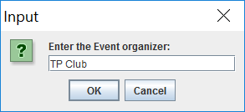  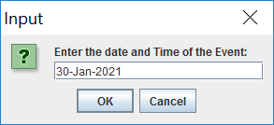  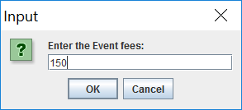
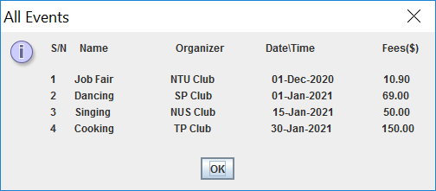 | ⬅ The new event is added.

Figure1.3: If the administrator chooses to add a new event, the program prompts the user to enter the name, organizer, fees and date and time of the new event. It then creates and adds in the new event.

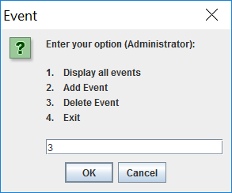 | 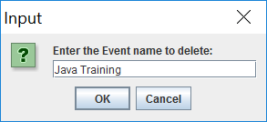  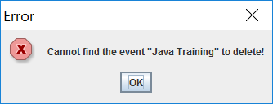  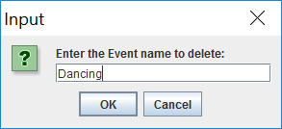  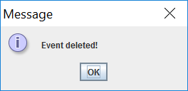
The event is deleted. ➔ | 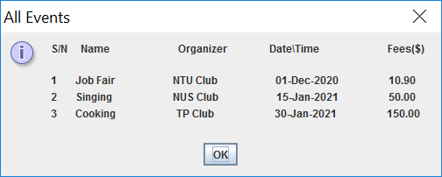
Figure1.4: If the administrator chooses to delete an event, the program prompts the user to enter the event name. It deletes the event if the event can be found. Otherwise, it displays an error message.

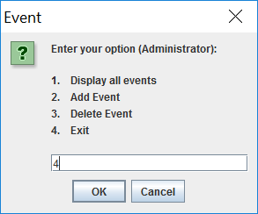 | 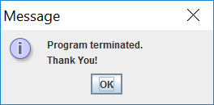

Figure1.5: If the administrator chooses to exit the program, it displays a thank you message and terminates the program.

Figure 2.1 to 2.5 shows what a normal user can do.

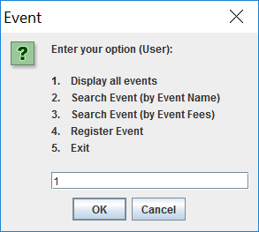

Figure 2.1: The program displays all events if the user selects option 1.

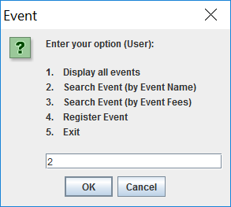 | 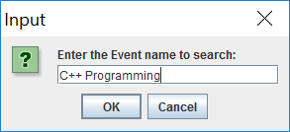  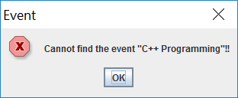  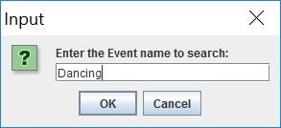  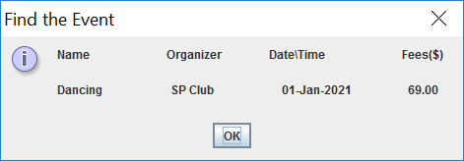
Figure 2.2: If the user wants to search an event by name, the program prompts the user to enter the name of event to search and displays the result accordingly.

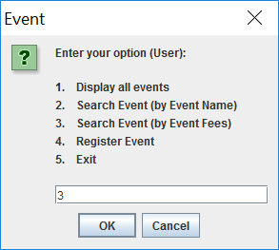 | 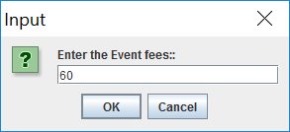  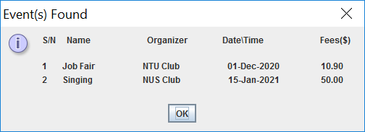

Figure 2.3: If the user wants to search the event by fees, the program prompts the user to enter the fees to search. It then finds and displays all the events that are having the fees less than the value entered.

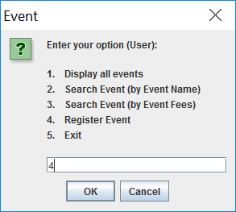 | 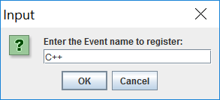  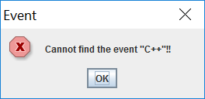  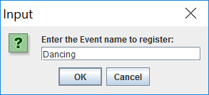  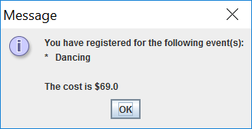
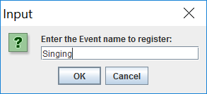

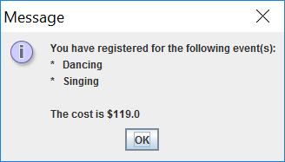

Figure 2.4: If the user wants to register event, the program prompts the user to enter the event name. It displays an error message if the event cannot be found. Otherwise, the program displays all the events that the user has registered and the total cost of the event(s).

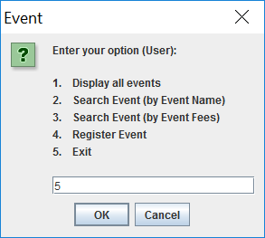

Figure 2.5: If the user chooses to exit the program, it displays a thank you message and terminates the program.

Basic Requirements

Write the Java programs using appropriate methods, objects and arrays to perform the tasks stated in Overview of the system section (shown in Fig1.1 to Fig 2.5).
Note: You should validate all the user inputs. If the input is invalid, the program displays an error message and prompts the user to re-enter.

1. Write a Java class Event (or similar class) to represent an event object, you should have instance variables to store the name, organizer, fees and date and time of the event, and any other properties to meet your requirements.
Add a constructor, appropriate get or set methods, or any other methods to the class if necessary.

2. Write a Java class EventManagement (or similar class) to manage the events. The class should have methods that will be invoked by the main method such as to create the event, display events, add event, delete event, and search event, …., etc. In this class, please create 3 Event objects and store in an array.

3. Write a Java class EventUser (or similar class) that contains the main() method for the entire application. The main() method is where your program will start to run. It displays menus and calls the methods in EventManagement class accordingly. You may add in other methods in EventUser class if necessary.

4. Implement the advanced features such as, but not limited to the followings:
- Validate for non-numeric input
- Sound effects.
- No duplicated event name can be added
- No date and time conflict when an user registers for events
- Allow administrator to edit the events
- Use Java Date and Time class instead of String to represent event date and time
- Store the event information in a file and retrieve the info from the file.
- Any other features that enhance the system.
Note: Do NOT implement Graphic User Interface (GUI) for the CA1 as this will be the requirement for CA2.

5. Zip the complete NetBeans project of your CA1 and submit to BlackBoard. Provide your Class, Admission Number and Name on each of the Java classes.

Please keep in mind that advanced features are just bonus features. The main bulk of marks are allocated to the completion of a workable program that meets the minimum requirements. You should try to fulfill the minimum requirements before you attempt to include any advance features.

Assessment Guidelines

The assignment will be assessed based on the following criteria:

- Ability to demonstrate the minimum requirements of the system

- Program design such as:
- Correct and efficient usage of classes and programming constructs
- Appropriate method decomposition
- Appropriate validations
- Code efficiency

- Program readability:
- Meaningful identifiers
- Meaningful comments and indentation in source code

- Innovation and creativity, and/or any advanced features

- Amount of individual contribution to the project

- Question & Answer during interview

-- End --

